StMM’s Car Pick-up (Be patient & remain calm!)
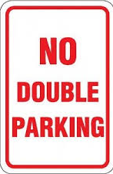
The Commander of Merrylands Highway Patrol has advised us that you will
8:30-9:30am
2:15-3:45pm
be booked and fined if you:
1. Park for more than 2 minutes after 2:15-3:45pm.
2. Double-park on the other side of Henson Street.
StMM’s suggests that you space your arrival between 3:00pm and 3:30pm.

StMM’s Car Pick-up (Be patient & remain calm!)
The Commander of Merrylands Highway Patrol has advised us that you will
8:30-9:30am
2:15-3:45pm
be booked and fined if you:
1. Park for more than 2 minutes after 2:15-3:45pm.
2. Double-park on the other side of Henson Street.
StMM’s suggests that you space your arrival between 3:00pm and 3:30pm.

StMM’s Car Pick-up (Be patient & remain calm!)
The Commander of Merrylands Highway Patrol has advised us that you will
8:30-9:30am
2:15-3:45pm
be booked and fined if you:
1. Park for more than 2 minutes after 2:15-3:45pm.
2. Double-park on the other side of Henson Street.
StMM’s suggests that you space your arrival between 3:00pm and 3:30pm.

